Department of Computer Engineering

University of Puerto Rico

Mayaguez Campus



**Team Members:**

Kevin Santiago Ortíz

José A. Rodríguez Rivera

Jariel O. Laureano Cruz

**Emails:**

[kevin.santiago1@upr.edu](mailto:kevin.santiago1@upr.edu)

[jose.rodriguez37@upr.edu](mailto:jose.rodriguez37@upr.edu)

[jariel.laureano@upr.edu](mailto:jariel.laureano@upr.edu)

**Introduction**

We live on a society that depends on science and technology. As technology advance our goal is making things easier. Things like cars, houses, and clothes advertisement are now performed online. The reason is not a mystery, is a cheaper and more efficient way to do it.

Moving on this line of reasoning, DealIt is a web application that offers a user friendly interface were can be placed sales/trades and special offers. The sales/trade transactions could be anything such as: vehicles, houses, electronics, furniture, and miscellaneous. As mentioned before sales/trades could be anything, so this web application targets everyone willing to sale/buy/trade something that fits in one of the above categories.

The technologies employed to develop DealIt are as follows:

*Front End*

* Angular JS
* Javascript
* Html
* Css
* Angular Material

*Middleware*

* Java Play

*Back End*

* PostgreSql

**Client App Description**

DealIt web application will have the following capabilities:

1. *User registration:*

Users that want to sign up would need to supply some information such as:

full name, city, cell phone number, email and a password. After submitting their

credentials a notification for email validation would be send for completing the

process. Another option

b) *Selling:*

For posting something for sell, a form will be supplied. To those that are

already registered, the contact information will be automatically fill up. In

change, those that want to continue as guest will need to supply all the required

data, and a post code will be send via text to the user for future post editing.

A description field would be supplied and the option for uploading a picture of the

item.

c) Buy/Trade:

A few methods will be supported in terms of buying or trading items. From

the most traditional ones such as: contacting the owner through the information

supplied on the advertisement. Also is possible to pay through credit card in

some cases. All the above mentioned would depend on the product owner and

obviously what classification we are talking about.

d) Product Filtering:

The interface will count with a filter that would be capable of search trough

the classifications making easier find things within the web app.

**Server App Description**

The server side of the web application will make possible the communication between the client and the database. In this way the information from the item and the people who own them will be stored at the database. The client side of the application would be worked using Angularjs which facilitates a lot things like the ajax calls for getting or posting data and other things such as the interface response.

Tables on our schema:

CREATE TABLE account (

aid integer NOT NULL,

uid integer,

_type character varying(10) NOT NULL,

sdate character(6) NOT NULL

);

CREATE TABLE category (

cid integer NOT NULL,

cname character varying(10)

);

CREATE TABLE credit_card (

crid integer NOT NULL,

aid integer,

cnumber character(16) NOT NULL,

ctype character varying(10) NOT NULL,

scode character(3),

expdate character(4),

bzip character(5),

bcity character varying(20),

country character(3),

bstate character(2),

baddress character varying(55)

);

CREATE TABLE feedback (

fid integer NOT NULL,

pid integer,

comnt character varying(50)

);

CREATE TABLE login_cred (

lid integer NOT NULL,

aid integer,

username character varying(30) NOT NULL,

_password character varying(30) NOT NULL

);

CREATE TABLE order_line (

olid integer NOT NULL,

pid integer,

oid integer,

quantity integer NOT NULL

);

CREATE TABLE orders (

oid integer NOT NULL,

aid integer,

_date character(6) NOT NULL

);

CREATE TABLE phone_numbers (

phid integer NOT NULL,

uid integer,

phone character(10) NOT NULL

);

CREATE TABLE product (

pid integer NOT NULL,

cid integer,

aid integer,

pname character varying(20) NOT NULL,

brand character varying(20) NOT NULL,

conditions character varying(20) NOT NULL,

price numeric(10,2) NOT NULL,

img_url character varying(200),

description character varying(1000)

);

CREATE TABLE users (

uid integer NOT NULL,

ufirst character varying(10) NOT NULL,

ulast character varying(10) NOT NULL,

ubirth character(6) NOT NULL,

uemail character varying(30) NOT NULL,

ucity character varying(15) NOT NULL,

ustate character varying(15) NOT NULL

);

*Users --* provide an ID and store all the information from the user. Will have

*Account* – Links information about the products that the user owns, and the orders he has made.

*Products --* The items posted will be stored here. Each item need a classification field that has to be consistent with the available classifications on the Items Classification table. All information about a product, description etc.

*Classification --* This table will contain all available classifications assigning them an

ID that can be used for the classification field on the Items table.

*Phones --* Contains all phones from users

*Feedback -- Contains feedback from users to products*

*Login* Cred– Credentials of each registered user.

*Order* – Order number,

*Order Line* - Contains information about the order such as which products are on the order and the quantity, etc.

Credit_card – Contains information of the credit card from users.

**E-R Diagram**

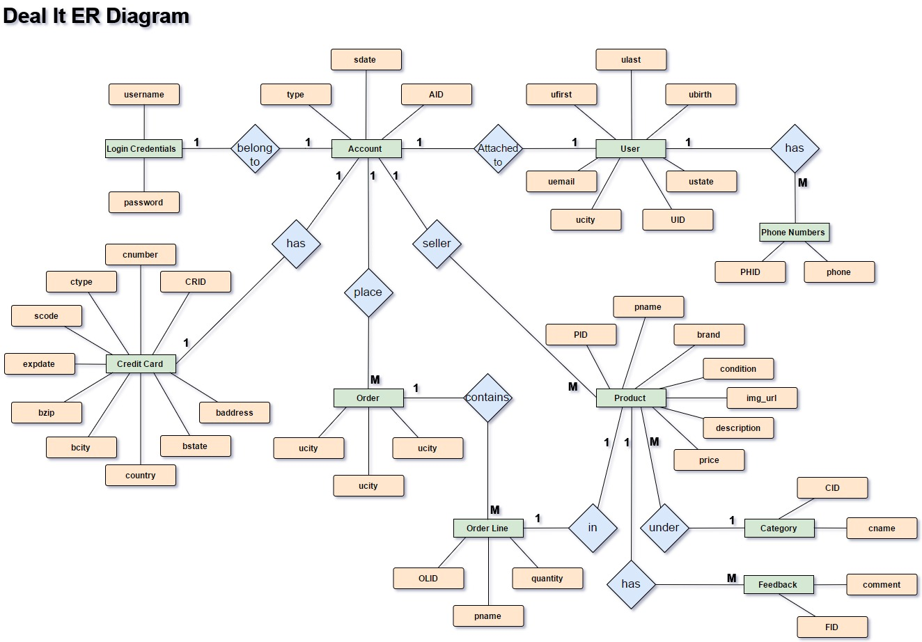

Each user will need credentials for login in. Every user has some information (User Info) that is bind to the account. User have the capability to acquire products or sale them. Each product has product details where is also stored a relation with the user that put it on sale. Each product also has a category under which it’s label. There is an entity order that contains the user and the order to create a relation with the user and the order details. The order detail contains all the information about the order such as how much product is buy, which ones are in the order and credit card used to pay for the order.

**Client Side -Screenshots**

Home Page Screenshot

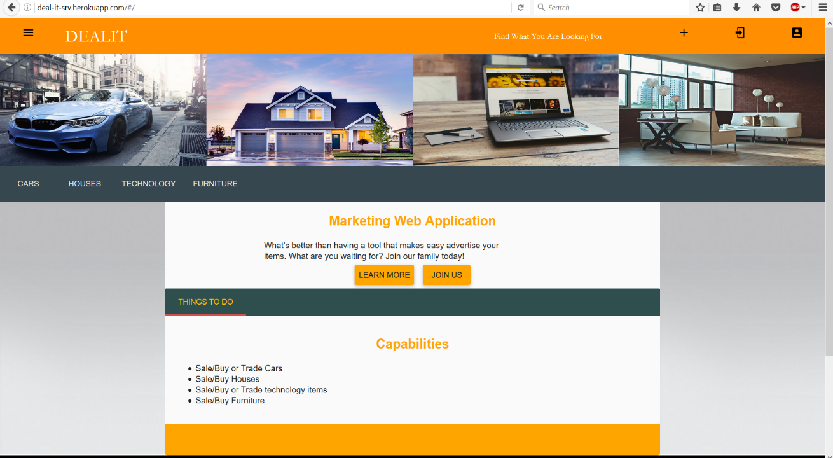

On the home page the user has access to information about the web application. Also this page contains menus and buttons with links to navigate through the app. The menu shown above have all the categories in which the user could search for anything they are looking for. Also there is a side navigation menu that popup on the left of the window with the use of the top left icon.

Login/Signup Screenshot

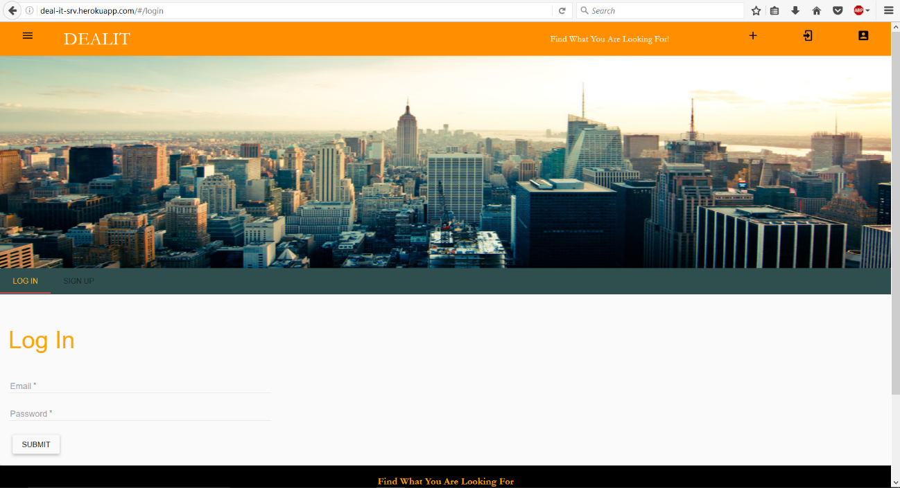

The login/signup view serve as an interface in which the user can login to his account. If the user doesn’t have an account, the form for signup is also available.

Category View Screenshot

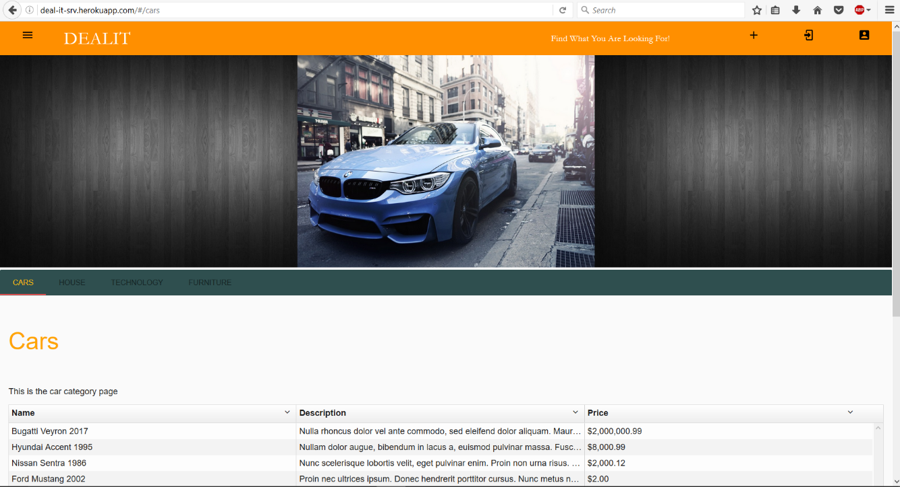

On the category view it’s presented a table with all the items which are labelled under that category, in this case cars. The user can click on any of the items for a more detailed view for that item.

Individual Item View

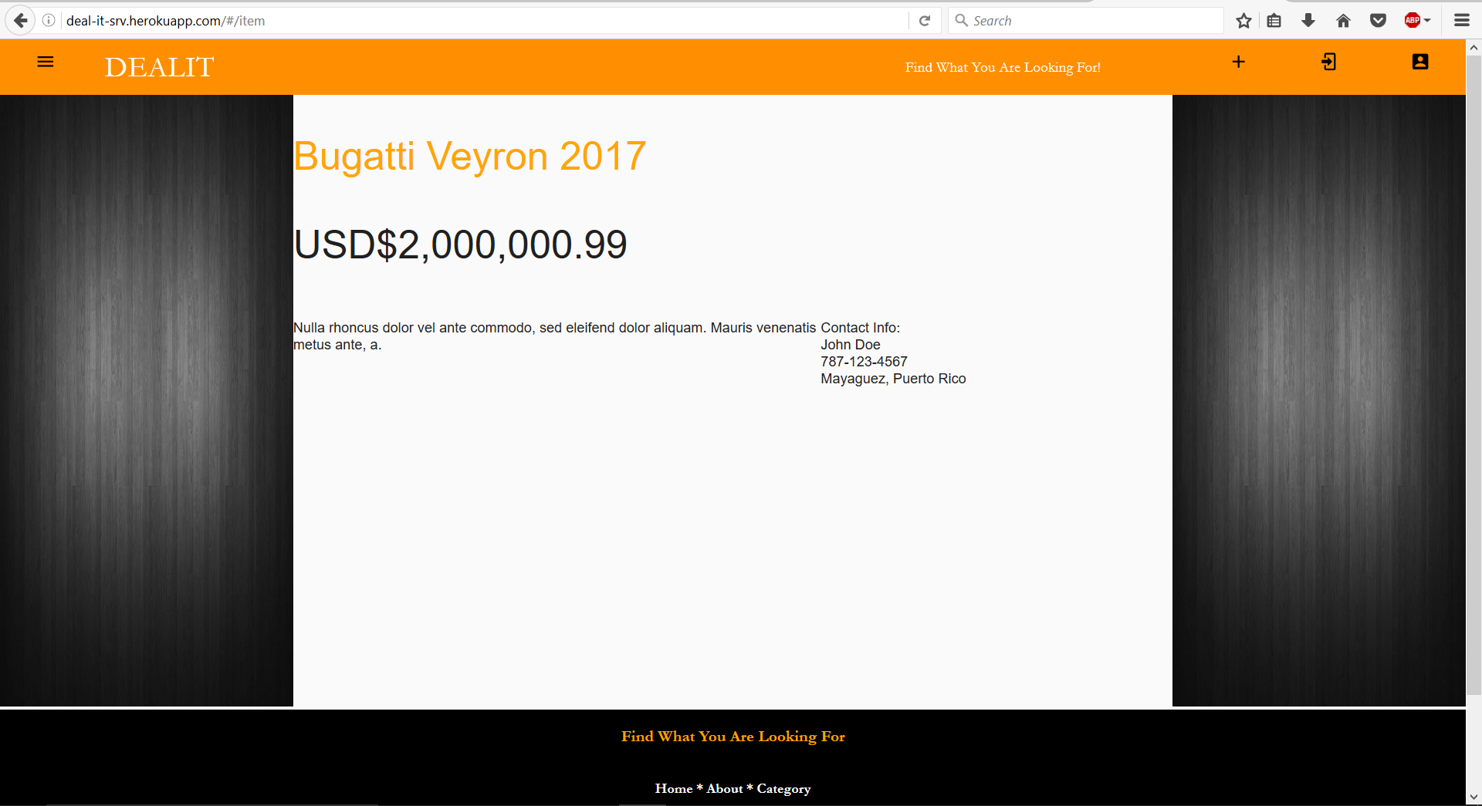

The individual item view its where all the important data about an item can be accessed by the user. Information such as price, description and contact information is something that can be expected.

Profile View

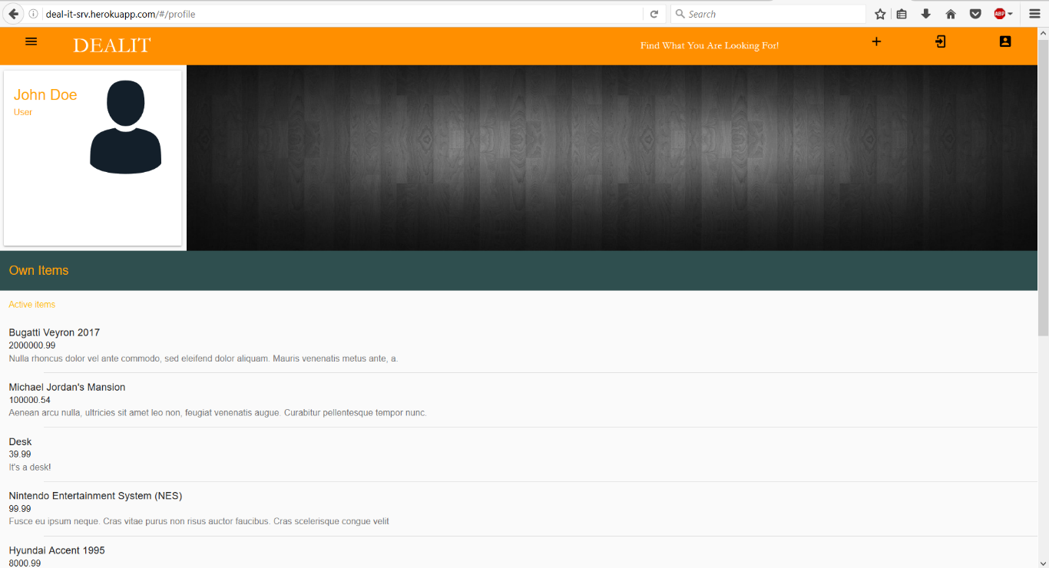

The profile view contains a list of items that are currently post and still active on the application by the user.

About View



The about view contains a little more information about the purpose of the web application and which is the scope of clients that it aims.